# Project Outcome for Public Libraries Report 2021–2023

Project Outcome is a FREE online toolkit designed to help public libraries understand and share the impact of essential library programs and services by providing simple surveys and easy-to-use process for measuring and analyzing outcomes. Participating libraries are also provided with the resources and training support needed to apply their results and confidently advocate for their library's future. Register for free at [projectoutcome.org](https://www.projectoutcome.org/) to learn more.

## Quick Stats

Since its launch in 2015, 12,264 registered users at 3,729 organizations have engaged with Project Outcome.

### Usage (2021–2023)

* Organizations: 532
* Surveys Created: 9,179
* Responses Collected: 100,339

## Summary

Project Outcome launched in June 2015 and had considerable growth in its first four years. The COVID-19 pandemic had a significant impact on library programming in 2020, and consequently also impacted Project Outcome use. This three-year report shows participating organizations and responses gathered annually have not returned to pre-2020 levels. However, many new users during this period used Project Outcome to measure the impact of grant-funded programs and community-specific services. These include PLA’s [Digital Literacy Initiative](https://www.ala.org/pla/initiatives/digitalliteracy) and the ALA [Public Programs Office’s Libraries Transform Communities Engagement Grant](https://www.ala.org/tools/programming/LTCEG). As a result, the Digital Learning and Education/Lifelong Learning survey topics show the most recent growth.

### Project Outcome Annual Usage

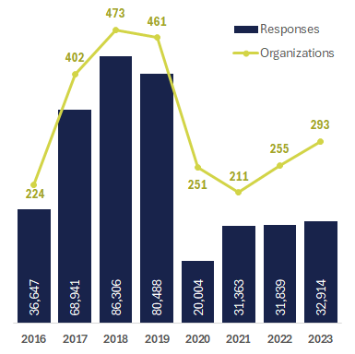

### Survey Responses by State

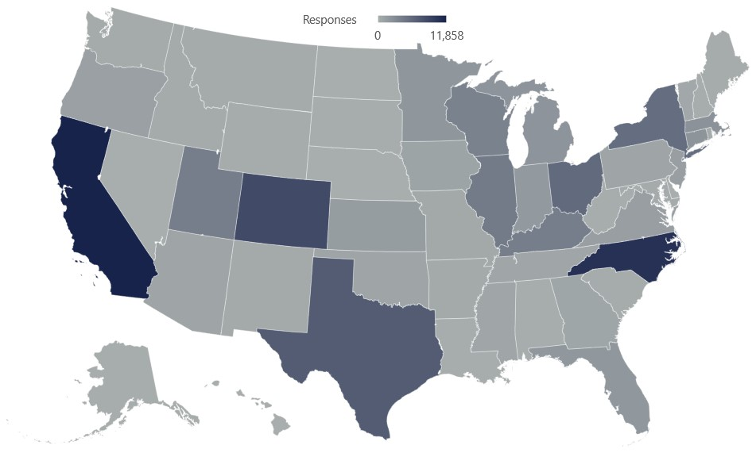

## Usage by Survey Topic

Education/Lifelong Learning

* Organizations: 235
* Responses: 37,995

Summer Reading

* Organizations: 134
* Responses: 27,341

Digital Learning

* Organizations: 259
* Responses: 14,597

Early Childhood Literacy

* Organizations: 94
* Responses: 11,270

Civic/Community Engagement

* Organizations: 83
* Responses: 2,724

Health

* Organizations: 40
* Responses: 1,516

Economic Development

* Organizations: 17
* Responses: 587

Job Skills

* Organizations: 28
* Responses: 417

Survey Spotlight**:** The Digital Learning Survey is used to evaluate programs and services that enable users to access technology, to build technology-related skills and confidence, and to increase their use of digital resources and services. Between 2021 and 2023:

* 94% of respondents felt more knowledgeable about using digital resources
* 92% felt more confident using digital resources
* 95% intend to apply what they learned
* 94% were more aware of resources and services provided by the library

## 2023 Project Outcome User Survey

“It really helped to change how I think about why we are offering programs. It has helped us focus on our mission, vision, and values and think about our programs through the eyes of our community.”

72% of respondents agree or strongly agree that using Project Outcome helps to improve assessment and evaluation practices in their library.

70% of respondents agree or strongly agree that Project Outcome helps them advocate for the value of library programs and services.

## New Features

* Administer online surveys with QR codes
* Supplement Project Outcome reports with saved infographics
* Tag surveys with [Sustainable Development Goals](https://www.ifla.org/wp-content/uploads/2019/05/assets/hq/topics/libraries-development/documents/sdgs-insert.pdf)
* Web accessibility upgrades to the website and toolkit, using [WebAIM’s WCAG 2](https://webaim.org/standards/wcag/checklist) as a guide

**Contact Us:**  [info@projectoucome.org](mailto:info@projectoucome.org) | [www.projectoutcome.org](http://www.projectoutcome.org)